Freshman Success

Greenville Technical Charter HS

Mrs. Brown- 1B-

[gbrown@staff.gtchs.org](mailto:gbrown@staff.gtchs.org)

Welcome!

Welcome to Freshman Success. This course is designed to provide basic information beneficial to all students new to Greenville Tech Charter High School. Among the many topics covered are school policies, academic goals, and career and college planning. Students will learn the strategies for study skills, note-taking, social-emotional strategies, and MLA writing format. While you are exploring your post-high school options, you will also work on developing critical thinking and learning skills. ***This class is not a Study Hall.***

Classroom Materials

* Agenda/Planner
* Pencils
* 1” Binder with eight dividers
* Folder (to be placed in binder)

Technology

Students are expected to bring a charged Chromebook to class daily. Technology will be used daily in classroom activities. Only GTCHS-issued Chromebooks will be allowed in class, and no personal devices, including cell phones or personal laptops, will be allowed. Students must place cell phones in the cell phone chart hanging on the door at the start of class.

Classroom Expectations

All students are expected to comply with Greenville Technical Charter High School’s guidelines and policies regarding student behavior.

In my classroom, I expect students to follow the three P’s:

1. Productive

* Students will work from bell to bell and engage in the lesson daily.

1. Prepared

* Come to class prepared. Before you come to class, use the restroom, get water, sharpen pencils, and complete homework. Being prepared will help you be successful.

1. Positive

* Respect is essential no matter where you are. Group work will be the norm in the classroom, and collaboration is best when students are positive. Negativity in any form will not be tolerated.

**Consequences:**

*1.* *Warning and conference with teacher. (parents contacted)*

*2.* *Lunch detention assigned. (parents contacted)*

*3.* *Administrative referral.*

Tardy Policy

Students who are tardy to class will report to the front office for a pass. You may not enter my classroom without a pass. 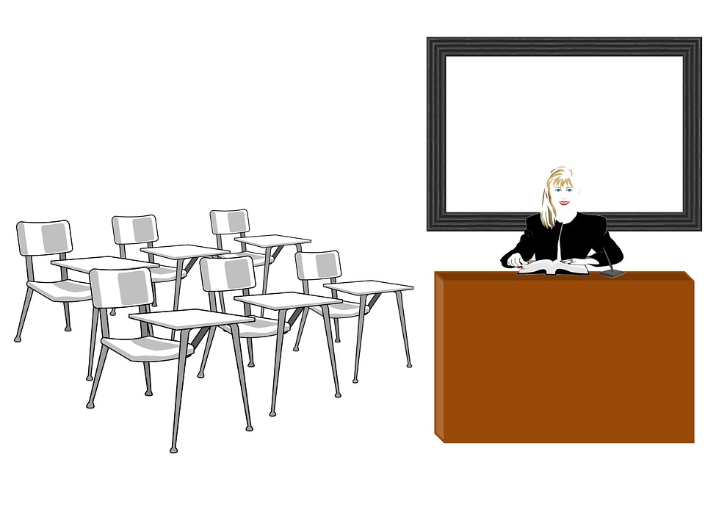

Classroom Procedures

These things should all be done as soon as you enter:

1. Get out your binder.

2. Grab a pencil.

3. Sit down at your seat.

4. Put cellular devices away

Late Work Policy

To prepare students for college and the workforce, students are required to turn in all work on time. A zero will be given for all work not turned in. Late work will lose 10 points for each **day** late. After the teacher reviews a homework assignment in class, it cannot be turned in for a grade, and the student will receive a zero for the grade. Homework is important and should be done nightly.

Absences

You are expected to refer to Google Classroom if you are absent. Homework is not accepted late. If a student would like credit for a homework assignment they missed, they must retrieve the assignment from the Google Classroom and have it (and the homework they were assigned from the previous class) ready to turn in when they return. Unless otherwise discussed, all other assignments must be made up within one week of the absence. Assignments not completed within one week will be inputted as a zero in the grade book. Students can make up missed quizzes and tests by appointment, before or after school. It is your responsibility to complete the missed work promptly.

Mastery Learning

As we are a mastery learning school, students can redo any significant assignment with a grade below 75. Students must complete a form of remediation before redoing the assignment. To redo an assignment, the student will come after school to work with Mrs. Brown on a designated Wednesday. Failure to complete the remediation or show up for this opportunity will result in the original grade becoming permanent. Retakes can earn a maximum grade of 90, and only one retake per major assignment is allowed.

Grading Scale

In addition to the progress reports that the school sends out, you should be checking your grade through PowerSchool and including it in your weekly academic reports. Please acknowledge our grading scale; *A: 100-90, B: 89-80, C: 79-75, F: 74 and below.*

Projects (40%): Projects will allow students to demonstrate mastery in the major units that we cover.

Classwork (35%): Classwork will include in-class activities completed for accuracy and/or completion and other forms of informal assessment within the classroom.

Journals & Other Reflection (25%): Students will have several opportunities to journal throughout Freshman Success. We will use journals to document progress over freshman year and reflect on what we have learned.

**The Midterm and Final exams are 10% of the respective semester average.

Extra Help

I offer help after school every Wednesday until 3:30 pm. Additional extra help may be scheduled by appointment. WIN is used for extra help on Tuesdays during school. You must report to WIN time with a grade of 80 or less.

**

Silent Sustained Reading

Students must bring a physical book (NO DEVICES) to class on their designated weekday to participate in SSR. Silent Sustained Reading is 20 minutes of time solely dedicated to reading for pleasure. Completing classwork, studying, or any other activity is not permitted during these 20 minutes.

A Day = Wednesday

B-Day = Thursday

"Reading as a teen leads to success. Research shows that when teens read more than just their classroom assignments, they generally do well in school. First, the extra reading expands their vocabularies. It also shows them how different writers put down their thoughts, which leads to better writing skills. And teens who read more serious literary works gain skills in handling complex ideas. The more teens read, the more information they pick up. This leads to a solid core of knowledge that is useful in a wide variety of classes. For example, the teen who reads biographies has a better understanding of prominent people studied in history classes.

Another big dividend of reading as a teen is a good score on the verbal section of a college admissions test. No other activity builds the vocabulary and comprehension skills needed to do well on these tests and reading."

"Besides helping teens do well in school, reading also helps them expand their horizons as they learn more about people and the world. Plus, reading can show teens that everyone has problems in his or her life and may even help teens see solutions to their problems. Finally, reading is enjoyable. It can bring a great deal of pleasure to teens."

"Parents can encourage their children to stay involved with reading by expressing interest in what they are reading and tying it to other activities. If a teen is fascinated by racing stories, try to take the child to a race. If a teen likes a book that has been turned into a movie, make sure he or she sees the movie."

*Peggy Gisler and Marge Eberts are experienced teachers with more than 60 educational publications. They began writing books together in 1979.*